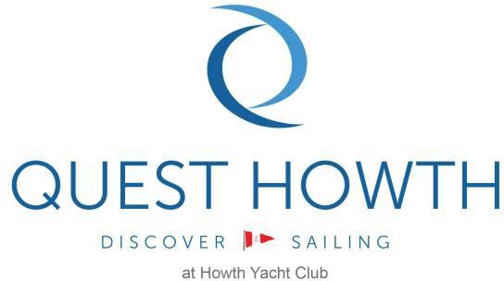
2022
Junior Summer Course Application Form

First Name | Surname | Course |  | Course Start Date
Click here to enter text. | Click here to enter text. | Course Name |  | Enter a date.
Address
Click here to enter text.
Please advise of any relevant medical conditions
Click here to enter text.
Please advise of level of swimming capabilities/water confidence
Click here to enter text.
Previous Sailing Experience
Click here to enter text.
Parent/Guardian Name | Contact Phone Number |  | Alternative Emergency Contact | Contact Phone Number
Parent/Guardian | Mobile Phone Number |  | Emergency Contact Name | Emergency Contact Number
Parent/Guardian e-mail address |  |  | Sailors date of birth | Permission to leave club
Contact E-mail. |  |  | Date of birth | Select Yes/No

Club boats are provided for all participants in Cara Na Mara & Keelboat Courses. Participants in other courses may use their own boat subjects to Note 1 below.  Boat charters are also available from HYC. | Junior Membership entitles sailors to attend summer courses and access to club facilities throughout the year. All juniors must have their membership applications approved prior to course start date. Please advise if you require a new members card for access. | Irish Sailing maintains an online database of training participants progress. In order to use Sailing Passport, they require participants first name, surname, date of birth and email address with Irish Sailing and Checklick Inc. Do you consent to  HYC sharing this data? | Howth Yacht Club sometimes uses photography/video for training and for promotion on our website and social media channels. Please select yes below if you agree to the use of photography/video.
Do you require a boat charter? Yes/No | Do you require a replacement members card? Yes/No | Select Yes/No | Select Yes/No
NOTE 1: If you are using your own boat or borrowing a boat, please ensure that it is insured and in good working order. Please check sails, spars, lines, foils, lines, buoyancy, bailers, painter and launching trolley at least one week before the course and repair/replace damaged equipment.

By completing this form I agree that I and my child will abide by the Clubs Code of Conduct and Terms and Conditions. Sailing, like all sports, carries a risk and that by completing the form, the applicant acknowledges this. The onus is on the applicant to inform Quest Howth/HYC of any medical or other condition that could affect his/her participation on the course.

COURSE PAYMENT: Upon receipt of a completed sailing application form we will contact you regarding payment. You can pay by phone, in person in our office during normal office hours or online through the members section of the HYC.ie site once you have received approval for your place in the course applied for. Fees must be paid in full 10 days prior to course start date.
SIGNATURE |  |  |  | DATE

2022
Junior Summer Course Application Form

INFORMATION FOR PARENTS AND SAILORS

WHAT YOU NEED TO BRING WITH YOU  - Non-slip Shoes or wetsuit booties  - Long Wetsuits and Cag (Waterproof spray top)  - Lifejacket / Buoyancy Aid  - Hat or Cap  - A change of clothes and towel  - Any medication you might need  - Sun Cream  - Please bring a drink and a light snack | GENERAL COURSE INFORMATION  - For all courses on the summer schedule you will be issued with a email 1 week in advance notifying you of start and finish times. Participants are asked to be on time and ready to go on the water each day at the time requested.  - Participants may book more than one course during the summer if your child would like progress further. Please ask your instructor if you would like more advice on this.  - All our instructors are experienced sailors and qualified ISA instructors. A strict safety ratio of sailors to instructors is maintained at Howth Yacht Club.  - The syllabus for the Irish Sailing is available to view on https://www.sailing.ie/Training/Courses/Dinghy-Sailing and you are encouraged to check out what is required for the level you are interested in.  - Additional courses may be provided during the summer, depending on demand and resources available, please contact us at (01) 8322141 or alternatively email us at quest@hyc.ie
BOOKING CONDITIONS

- Quest Howth reserves the right to cancel a course if there are insufficient bookings. Fees will be refunded if we cancel a course.

- Sailing is a weather dependant sport and every effort will be made to make the best use of the prevailing and forecast conditions at the time of the course. Only in exceptional circumstances will Quest Howth decide to reschedule a course due to weather conditions. In such circumstances every effort will be made to accommodate applicants on suitable alternative dates.

- Trainees agree to abide by Quest Howth/Howth Yacht Clubs’ Code of Conduct.

Privacy and Data Protection. By this application you consent to your details on this application form being retained and processed by HYC in accordance with GDPR. HYC’s Privacy and Data Protection Policy is published on hyc.ie and is also available from the Administration Office.

